FPT UNIVERSITY
INFORMATION SYSTEMS MAJOR
FACULTY OF INFORMATION TECHNOLOGY



ASSIGNMENT REPORT

DATABASE DESIGN

SUPERVISOR : Mrs. NGUYỄN THỊ THU THẢO
GROUP : 7
SUBJECT : DB1202
CLASS : SE1913
HO CHI MINH CITY 11/2025

ASSIGNMENT
Project Title: Banking System
Course: DBI202 | Instructor: Ms. Nguyễn Thị Thu Thảo
ClassID: SE1913
Group ID: 7
Group Members:
Student ID | Full Name | Group | Group Mark | Contribution  (%) | Mark | Note
SE203334 | Hà Nguyễn Tiến Đạt | 7 |  | 100
SE190596 | Trần Hữu Việt | 7 |  | 100
SE193659 | Mai Thành Được | 7 |  | 100
SS190849 | Lê Nguyên Ngọc | 7 |  | 100

Contents
I. INTRODUCTION 3
1. Introduction 3
2. Project Objectives 3
3. Overview of data models 3
4. Proposed Data Model / Design 3
II. HIGH-LEVEL DESIGN 4
1. Scenario 4
2. Identify entities, relationships and their properties 4
3. Create the Conceptual Model (ERD) 4
4. Develop the Logical Model (RD schems) 5
III. LOGICAL DESIGN 6
1. Determine the functional dependencies 6
2. Find the keys 7
IV. NORMALIZATION 8
1. Anomaly Detection and Normalization 8
2. Identify Normal Forms 8
3. Perform Decomposition 9
4. Final Normalized Schema 10
V. PHYSICAL DESIGN 11
1. Design the Physical Model 11
2. Basic retrieval to advanced operations 13
VI. CONCLUSION 15
1. AI Utilization 15
2. Teamwork & Collaboration 16

INTRODUCTION

Introduction
The objective of this project is to develop a comprehensive database system for a banking organization. The system is designed to manage daily operations, including customer records, accounts, loans, transactions, and employees. The final system ensures security, reliability, and support for regulatory compliance, providing a foundation for effective customer service and financial management.

Project Objectives
- Manage customers, accounts, and transactions (deposit, withdrawal, transfer).
- Support branch and employee management.
- Manage loans and generate reports.
- Provide secure login, multi-factor authentication, and audit logging.

Overview of data models
We analyzed four primary data models:
- Structured (RDBMS): Ideal for core financial data requiring high consistency and ACID compliance.
- Semi-Structured (NoSQL/JSON): Best for flexible data like varied customer profiles.
- Unstructured (Blob Storage): Suited for storing large files like scanned KYC documents.
- Graph (Graph DB): Excellent for analyzing complex relationships, such as in fraud
detection.

Proposed Data Model / Design
After evaluating the project's core requirements, we propose a hybrid design with the Structured (RDBMS) model as its foundation.
- Core System (RDBMS): The RDBMS model was chosen for managing all critical financial entities, which our team decomposed into six core components: customers, accounts, branches, employees, loans, and transactions. This approach guarantees the high consistency, reliability, and ACID compliance essential for financial operations.
- Supplemental Models: While the RDBMS is central, the system is designed to integrate with other models for specific functions:
  - Unstructured (Blob Storage) is recommended for storing static assets like scanned KYC (Know Your Customer) documents.
  - Graph (Graph DB) is proposed for future implementation of advanced features, such as real-time fraud detection, by analyzing complex transaction relationships.
This report will focus primarily on the design and implementation of the core RDBMS component.

HIGH-LEVEL DESIGN

Scenario
The banking system is based on the following business rules:
- A branch can serve multiple customers.
- Branches are identified by a Branch ID, branch name, phone number, and address.
- Customers are identified by a Customer ID, full name, date of birth (DOB), address, phone number, and sex.
- A customer can have one or more accounts.
- Accounts are identified by an Account ID, account type, balance, status, open date, the associated Branch ID, and the associated Customer ID.
- A customer can avail of one or more loans. A loan can also be associated with multiple customers.
- Loans are identified by a Loan ID, loan type, loan amount, start date, status, the
associated Branch ID.
- Employees are associated with branches in two ways:
  - An employee works for one specific branch.
  - An employee manages one specific branch.
- All account activities (deposit, withdrawal, and transfer) are recorded in a single TRANSACTIONS table.

Identify entities, relationships and their properties
The core entities identified for the RDBMS portion of the system are:
- EMPLOYEE
- BRANCH
- CUSTOMER
- ACCOUNT
- LOAN
- TRANSACTIONS
- BRANCH_MANAGEMENT (decomposed from the 1:1 "manages" rule)
- CUSTOMER_LOAN (decomposed from the N:M "borrow" rule)

Create the Conceptual Model (ERD)
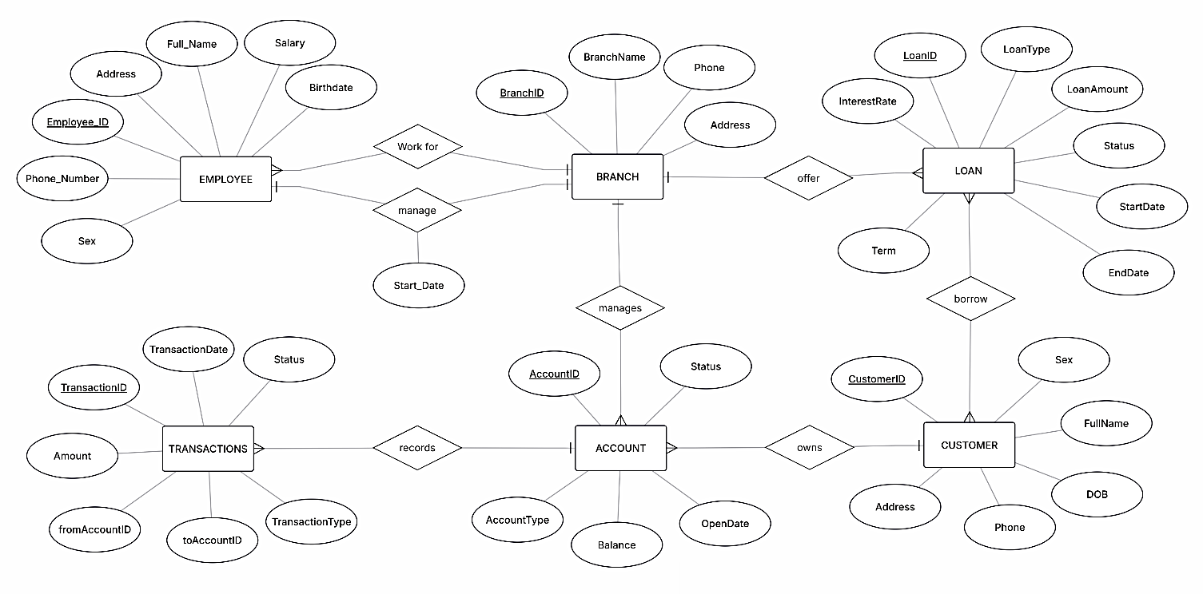
The conceptual model was developed to identify the core components of the banking system. This ERD clearly identifies the system's entities, their attributes, and the relationships between them, including cardinalities.
ERD Description:
Entities: EMPLOYEE, BRANCH, CUSTOMER, ACCOUNT, LOAN, TRANSACTIONS.
Attributes:
- EMPLOYEE: Employee_ID, Full_Name, Address, Phone_Number, Sex, Birthdate, Salary
- BRANCH: BranchID, BranchName, Phone, Address
- CUSTOMER: CustomerID, FullName, DOB, Address, Phone, Sex
- ACCOUNT: AccountID, AccountType, Balance, Status, OpenDate
- LOAN: LoanID, LoanType, LoanAmount, StartDate, EndDate, Term, Status, InterestRate
- TRANSACTIONS: TransactionID, TransactionDate, Status, TransactionType, Amount, fromAccountID, toAccountID
Relationships & Cardinalities:
- An EMPLOYEE work for one BRANCH (N:1).
- An EMPLOYEE manages one BRANCH (1:1), resolved via the BRANCH_MANAGEMENT table.
- A BRANCH manages many ACCOUNTS (1:N).
- A BRANCH offers many LOANS (1:N).
- A CUSTOMER owns many ACCOUNTS (1:N).
- Many CUSTOMER borrow many LOANS (N:M), resolved via the CUSTOMER_LOAN
linking table.
- An ACCOUNT records many TRANSACTIONS (1:N), implemented via fromAccountID and toAccountID to handle all transaction types.

Develop the Logical Model (RD schems)
The ERD was converted into a relational schema (Logical Diagram). This process involved defining primary and foreign keys and implementing the linking tables identified during decomposition.
Relational Schema:
BRANCH (BranchID, BranchName, Phone, Address)
CUSTOMER (CustomerID, FullName, DOB, Address, Phone, Sex)

EMPLOYEE (EmployeeID, Full_Name, Address, Phone_Number, Sex, Birthdate, Salary, BranchID)
- BranchID (FK) → BRANCH.BranchID
BRANCH_MANAGEMENT (BranchID, ManagerID)
- BranchID (FK) → BRANCH.BranchID
- ManagerID (FK, Unique) → EMPLOYEE.Employee_ID
ACCOUNT (AccountID, AccountType, Balance, Status, OpenDate, CustomerID, BranchID)
- CustomerID (FK) → CUSTOMER.CustomerID
- BranchID (FK) → BRANCH.BranchID
LOAN (LoanID, LoanType, LoanAmount, StartDate, EndDate, Term, Status, InterestRate, BranchID)
- BranchID (FK) → BRANCH.BranchID
CUSTOMER_LOAN (CustomerID, LoanID)
- CustomerID (FK) → CUSTOMER.CustomerID
- LoanID (FK) → LOAN.LoanID
TRANSACTIONS (TransactionID, TransactionDate, Status, TransactionType, Amount, fromAccountID, toAccountID)
- FromAccountID (FK) → ACCOUNT.AccountID
- ToAccountID (FK) → ACCOUNT.AccountID

LOGICAL DESIGN

Determine the functional dependencies
- Branch
BranchID → BranchName, Phone, Address
(The branch ID uniquely determines the branch name, and address)
- Customer
CustomerID → FullName, DOB, Address, Phone, Sex
(CustomerID uniquely determines the customer's name, date of birth, address, phone, and gender)
- Employee
Employee_ID → Full_Name, Address, Phone_Number, Sex, Birthdate, Salary, BranchID
(EmployeeID uniquely determines all personal and employment details of the employee)
- Account
AccountID → AccountType, Balance, Status, OpenDate, CustomerID, BranchID
(AccountID uniquely determines the account type, balance, status, open date, customer, and branch)
- Loan
LoanID → LoanType, LoanAmount, StartDate, EndDate, Term, Status, InterestRate, BranchID
(LoanID uniquely determines the loan type, amount, start date, end date, term, status,
interest rate and the associated branch)
- Transactions
TransactionID → TransactionDate, Status, TransactionType, Amount, fromAccountID, toAccountID
(TransactionID uniquely determines all details of the transaction, including its type, status, amount, and the associated source (from) and destination (to) accounts)
- Branch_Management
BranchID → ManagerID
ManagerID → BranchID
(Due to the UNIQUE constraint on ManagerID, ensuring a 1:1 relationship)
- Customer_Loan:
(No non-key attributes. The entire relation is a composite key).
Pattern Recognition Process
To identify functional dependencies (FDs), our team analyzed the relationships among
attributes within each entity in the relational schema. We identified attributes that are uniquely determined by others (for example, a unique identifier such as Employee_ID, BranchID, or CustomerID). By comparing sample data and observing which attributes consistently appeared together, we recognized patterns such as:
- BranchID uniquely determined the branch name, phone number, and address.
- CustomerID uniquely determined the customer's full name, date of birth (DOB), address, phone number, and sex.
- Employee_ID consistently determined an employee's full name, address, phone number, sex, birthdate, salary, and BranchID.
- AccountID uniquely determined the account type, balance, status, open date, BranchID, and CustomerID.
- LoanID uniquely determined the loan type, loan amount, start date, end date, term, status, interest rate, and BranchID.
- TransactionID uniquely determined all details for a single event (date, type, amount), including both the source (fromAccountID) and destination
(toAccountID). This unified pattern was recognized to cover deposits,
withdrawals, and transfers.
- The 1:1 "manages" rule was recognized as a pattern requiring its own relation (Branch_Management) to enforce the unique mapping from a manager to a branch.
- The N:M "borrow" rule was recognized as a pattern with no simple
determinant, requiring a composite key linking table (Customer_Loan).
These patterns helped us define the FDs and ensure that the database model reflects
real-world constraints accurately.
Algorithmic Reasoning Steps
To systematically derive the FDs and keys, our group followed a step-by-step reasoning process:
- Identify Determinants: We started by identifying unique identifiers (determinants) for each entity, such as:
Employee_ID for the Employee entity.
BranchID for the Branch entity.
CustomerID for the Customer entity.
AccountID for the Account entity.
LoanID for the Loan entity.
TransactionID for the Transaction entity.
BranchID and ManagerID for the Branch_Management entity.
{CustomerID, LoanID} for the Customer_Loan entity.
- Find Dependent Attributes: Next, we identified the attributes that depend on these determinants (e.g., BranchID → BranchName, Phone, Address in the Branch
table)
- Compute Attribute Closure: We performed closure checks to ensure there was no redundancy. This helped confirm that each determinant could uniquely determine all other attributes in the entity. For instance:
Employee_ID → {Full_Name, Address, Phone_Number, Sex, Birthdate, Salary, BranchID}
BranchID → {BranchName, Phone, Address}
- Determine Candidate Keys: Attributes with full closures were selected as candidate keys.
- Choose Primary Keys: From the candidate keys, we selected the most suitable
primary key based on simplicity and clarity.
This logical process made it easier to derive correct dependencies and ensure normalization consistency.

Find the keys
Entity | Candidate Key(s) | Primary Key
BRANCH | {BranchID} | BranchID
CUSTOMER | {CustomerID} | CustomerID
EMPLOYEE | {EmployeeID} | EmployeeID
ACCOUNT | {AccountID} | AccountID
LOAN | {LoanID} | LoanID
TRANSACTIONS | {TransactionID} | TransactionID
BRANCH_MANAGEMENT | {BranchID}, {ManagerID} | BranchID
CUSTOMER_LOAN | {CustomerID, LoanID} | {CustomerID, LoanID}

NORMALIZATION

Anomaly Detection and Normalization
The initial database design may encounter several anomalies such as:
Redundancy anomaly:
Employee information may be repeated for each branch they work in, leading to duplicated
data.
Update anomaly:
If an employee’s branch address changes, all related records must be updated manually,
increasing the risk of inconsistency.
Insertion anomaly:
It is impossible to add a new branch without assigning at least one employee because of the foreign key dependency.
Deletion anomaly:
Deleting a branch that an employee belongs to may cause the loss of related employee
information.

Identify Normal Forms
We analyze each relation based on the Relational Schema to determine its normal form.
BRANCH (BranchID, BranchName, Phone, Address)
FD: BranchID → BranchName, Phone, Address
→ All attributes depend on a single primary key.
→ In BCNF
CUSTOMER (CustomerID, FullName, DOB, Address, Phone, Sex)
FD: CustomerID → FullName, DOB, Address, Phone, Sex
→ All attributes depend on the primary key.
→ In BCNF
EMPLOYEE (EmployeeID, Full_Name, Address, Phone_Number, Sex, Birthdate, Salary, BranchID)
FDs: EmployeeID → Full_Name, Address, Phone_Number, Sex, Birthdate, Salary, BranchID
→ All non-key attributes depend fully on the primary key.
→ In BCNF
ACCOUNT (AccountID, AccountType, Balance, Status, OpenDate, CustomerID, BranchID)
FD: AccountID → AccountType, Balance, Status, OpenDate, CustomerID, BranchID
→ The primary key determines all other attributes.
→ In BCNF
LOAN (LoanID, LoanType, LoanAmount, StartDate, EndDate, Term, Status, InterestRate, BranchID)
FD: LoanID → LoanType, LoanAmount, StartDate, EndDate, Term, Status, InterestRate, BranchID
→ Fully functionally dependent on the primary key.
→ In BCNF
TRANSACTIONS (TransactionID, TransactionDate, Status, TransactionType, Amount, fromAccountID, toAccountID)
FD: TransactionID → TransactionDate, Status, TransactionType, Amount, fromAccountID, toAccountID
→ All non-key attributes depend only on the primary key.
→ In BCNF
BRANCH_MANAGEMENT (BranchID, ManagerID)
FDs: BranchID → ManagerID, ManagerID → BranchID.
Both determinants are candidate keys.
→ In BCNF
CUSTOMER_LOAN (CustomerID, LoanID)
This relation has no non-key attributes.
→ In BCNF

Perform Decomposition
The normalization of our database to BCNF (as identified in the previous step) was achieved precisely through the Decomposition process. The initial conceptual design (in Part II) would have suffered from anomalies if not for these crucial decompositions:
- N:M Decomposition (Loan-Customer): The conceptual "borrow" (N:M) relationship was decomposed into the Customer_Loan relation . This is the standard algorithmic step to
resolve a many-to-many relationship, preventing data redundancy and update anomalies.
- 1:1 Decomposition (Employee-Branch): The "manages" (1:1) relationship was
decomposed into the Branch_Management relation. This resolves potential update
anomalies, avoids NULL values (which would occur if ManagedBranchID were stored in
Employee ), and ensures the 1:1 constraint is strictly enforced.
- Logic Decomposition (Transactions): The business logic for transactions was unified.
Instead of the old two-table model (Transactions and Transfer), we recognized the pattern could be decomposed into a single Transactions table using two foreign keys (fromAccountID, toAccountID).
This decomposition process ensures the final schema is in BCNF, maintains the Lossless Join property, and preserves dependencies.

Final Normalized Schema
All relations satisfy BCNF, ensuring:
- No redundancy or anomaly issues
- Data integrity and consistency
- Efficient updates and scalability
1. Branch
- BranchID (Primary Key)
- BranchName
- Phone
- Address
2. Customer
- CustomerID (Primary Key)
- FullName
- DOB
- Address
- Phone
- Sex
3. Employee
- EmployeeID (Primary Key)
- Full_Name
- Address
- Phone_Number
- Sex
- Birthdate
- Salary
- BranchID (Foreign Key → BRANCH.BranchID)
4. Branch_Management
- BranchID (Primary Key, Foreign Key → BRANCH.BranchID)
- ManagerID (Unique, Foreign Key → EMPLOYEE.Employee_ID)
5. Account
- AccountID (Primary Key)
- AccountType
- Balance
- Status
- OpenDate
- CustomerID (Foreign Key → Customer.CustomerID)
- BranchID (Foreign Key → Branch.BranchID)
6. Loan
- LoanID (Primary Key)
- LoanType
- LoanAmount
- StartDate
- EndDate
- Term
- Status
- InterestRate
- BranchID (Foreign Key → Branch.BranchID)

7. Customer_Loan
- CustomerID (Primary Key, Foreign Key → CUSTOMER.CustomerID)
- LoanID (Primary Key, Foreign Key → LOAN.LoanID)
8. Transactions
- TransactionID (Primary Key)
- TransactionDate
- Status
- TransactionType
- Amount
- fromAccountID (Foreign Key → ACCOUNT.AccountID)
- toAccountID (Foreign Key → ACCOUNT.AccountID)

PHYSICAL DESIGN

Design the Physical Model
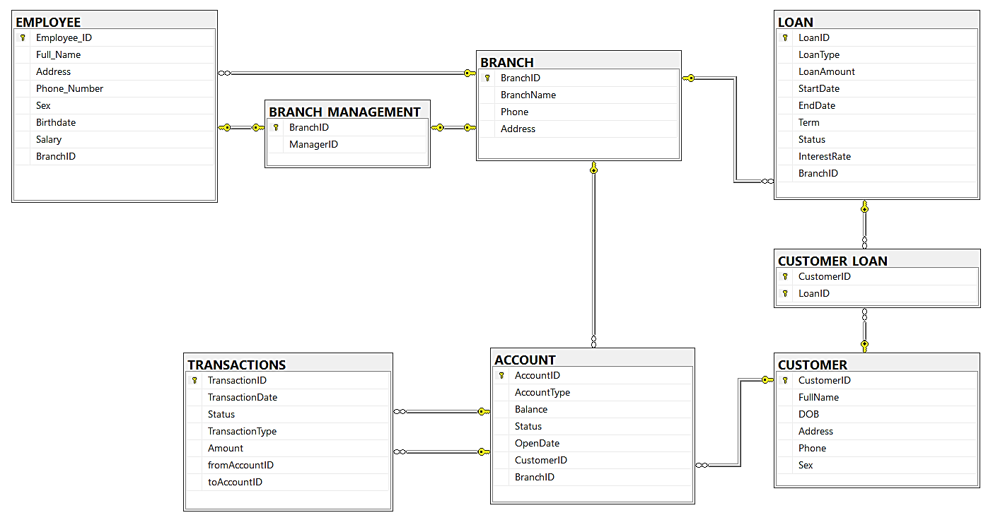
The logical schema was mapped to a physical model, defining specific data types and properties for implementation in a SQL database.
Table Definitions:
CREATE TABLE BRANCH (
BranchID INT PRIMARY KEY,
BranchName VARCHAR(255) NOT NULL UNIQUE,
Phone VARCHAR(20),
Address VARCHAR(255)
)
CREATE TABLE CUSTOMER (
CustomerID INT PRIMARY KEY,
FullName VARCHAR(255) NOT NULL,
DOB DATE,
Address VARCHAR(255),
Phone VARCHAR(20) NOT NULL UNIQUE,
Sex VARCHAR(10) CHECK (Sex IN ('Male', 'Female')) NOT NULL
)

CREATE TABLE EMPLOYEE (
Employee_ID INT PRIMARY KEY,
Full_Name VARCHAR(255) NOT NULL,
Address VARCHAR(255),
Phone_Number VARCHAR(20) NOT NULL UNIQUE,
Sex VARCHAR(10) CHECK (Sex IN ('Male', 'Female')),
Birthdate DATE,
Salary DECIMAL(15,2) NOT NULL CHECK (Salary > 0),

BranchID INT NOT NULL,
FOREIGN KEY (BranchID) REFERENCES BRANCH(BranchID)
)

CREATE TABLE BRANCH_MANAGEMENT (
BranchID INT PRIMARY KEY,
ManagerID INT NOT NULL UNIQUE,

FOREIGN KEY (BranchID) REFERENCES BRANCH(BranchID),
FOREIGN KEY (ManagerID) REFERENCES EMPLOYEE(Employee_ID)
)

CREATE TABLE ACCOUNT (
AccountID INT PRIMARY KEY,
AccountType VARCHAR(100) NOT NULL,
Balance DECIMAL(12,2) NOT NULL CHECK (Balance >= 0) DEFAULT 0,
Status VARCHAR(50) NOT NULL CHECK (Status IN ('Active', 'Closed', 'Frozen')),
OpenDate DATE NOT NULL,

CustomerID INT NOT NULL,
BranchID INT NOT NULL,

FOREIGN KEY (CustomerID) REFERENCES CUSTOMER(CustomerID),
FOREIGN KEY (BranchID) REFERENCES BRANCH(BranchID)
)

CREATE TABLE LOAN (
LoanID INT PRIMARY KEY,
LoanType VARCHAR(100) NOT NULL,
LoanAmount DECIMAL(12,2) NOT NULL CHECK (LoanAmount > 0),
StartDate DATE NOT NULL,
EndDate DATE,
Term VARCHAR(50),
Status VARCHAR(50) NOT NULL CHECK (Status IN ('Pending', 'Approved', 'Paid Off', 'Default')),
InterestRate DECIMAL(5,2) NOT NULL CHECK (InterestRate >= 0),
BranchID INT NOT NULL,
FOREIGN KEY (BranchID) REFERENCES BRANCH(BranchID)
)

CREATE TABLE CUSTOMER_LOAN (
CustomerID INT NOT NULL,
LoanID INT NOT NULL,

PRIMARY KEY (CustomerID, LoanID),
FOREIGN KEY (CustomerID) REFERENCES CUSTOMER(CustomerID),
FOREIGN KEY (LoanID) REFERENCES LOAN(LoanID)
)

CREATE TABLE TRANSACTIONS (
TransactionID INT PRIMARY KEY,
TransactionDate DATETIME NOT NULL DEFAULT CURRENT_TIMESTAMP,

Status VARCHAR(50) NOT NULL,
TransactionType VARCHAR(50) NOT NULL,
Amount DECIMAL(12,2) NOT NULL CHECK (Amount > 0),

fromAccountID INT,
toAccountID INT,

FOREIGN KEY (fromAccountID) REFERENCES ACCOUNT(AccountID),
FOREIGN KEY (toAccountID) REFERENCES ACCOUNT(AccountID),
CHECK (fromAccountID IS NOT NULL OR toAccountID IS NOT NULL)
)

Basic retrieval to advanced operations
SQL Queries
Basic:
- Description: Retrieve all customers in the system.
SELECT * FROM CUSTOMER
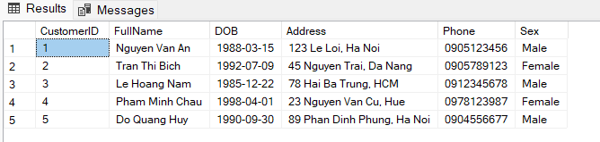
- Description: Find all employees who work in BranchID = 1 and have a salary over 17,000,000.
SELECT Employee_ID, Full_Name, Salary, BranchID FROM EMPLOYEE
WHERE BranchID = 1 AND Salary > 17000000
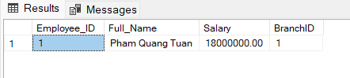
- Description: List transactions from October 12th to October 21st, 2024, sorted by date.
SELECT * FROM TRANSACTIONS
WHERE TransactionDate >= '2024-10-12' AND TransactionDate <= '2024-10-21'
ORDER BY TransactionDate
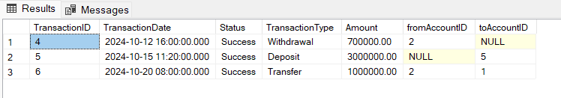
- Description: Count the total number of customers.
SELECT COUNT(CustomerID) AS TotalCustomers FROM CUSTOMER
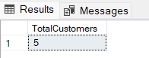
Intermediate:
- Description: Retrieve the customer's FullName, AccountID and the Balance of all
accounts they own.
SELECT c.FullName, a.AccountID, a.Balance
FROM CUSTOMER c
JOIN ACCOUNT a ON c.CustomerID = a.CustomerID
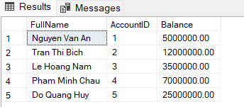
- Description: Show all branches and the count of employees in each (even if a branch has zero employees).
SELECT b.BranchName, COUNT(e.Employee_ID) AS EmployeeCount
FROM BRANCH b
LEFT JOIN EMPLOYEE e ON b.BranchID = e.BranchID
GROUP BY b.BranchName
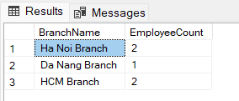
- Description: Count the number of loans per BranchID.
SELECT BranchID, COUNT(LoanID) AS LoanCount
FROM LOAN
GROUP BY BranchID
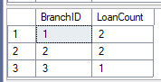
- Description: Show customers who have a total loan amount greater than 40,000,000.
SELECT cl.CustomerID, SUM(l.LoanAmount) AS TotalLoans
FROM LOAN l
JOIN CUSTOMER_LOAN cl ON l.LoanID = cl.LoanID
GROUP BY cl.CustomerID
HAVING SUM(l.LoanAmount) > 40000000;
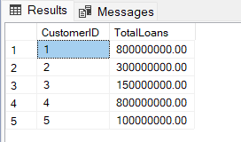
- Description: Find accounts that have sent or withdrawn transactions greater than 1,000,000.
SELECT AccountID, Balance FROM ACCOUNT
WHERE AccountID IN (
SELECT fromAccountID FROM TRANSACTIONS
WHERE Amount > 1000000 AND fromAccountID IS NOT NULL
);
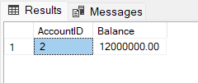
- Description: Find employees who earn more than the average salary of employees in 'HCM Branch'.
SELECT Full_Name, Salary FROM EMPLOYEE
WHERE Salary > (
SELECT AVG(Salary) FROM EMPLOYEE
WHERE BranchID = (
SELECT BranchID FROM BRANCH
WHERE BranchName = 'HCM Branch')
)
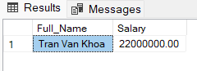
Advanced:
- Description: Find the FullName of customers who have a balance higher than the average balance of all 'Savings' accounts.
SELECT FullName FROM CUSTOMER
WHERE CustomerID IN (
SELECT CustomerID FROM ACCOUNT
WHERE Balance > (
SELECT AVG(Balance) FROM ACCOUNT
WHERE AccountType = 'Savings'
)
)
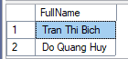
- Description: Find all customers who have at least one 'Active' account.
SELECT c.FullName
FROM CUSTOMER c
WHERE EXISTS (
SELECT 1 FROM ACCOUNT a
WHERE a.CustomerID = c.CustomerID AND a.Status = 'Active'
)
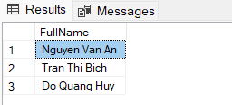
- Description: Find the names of customers who have an 'Active' account that has
received a deposit over 1,000,000.
SELECT FullName FROM CUSTOMER
WHERE CustomerID IN (
SELECT CustomerID FROM ACCOUNT
WHERE Status = 'Active' AND AccountID IN (
SELECT toAccountID FROM TRANSACTIONS
WHERE Amount > 1000000 AND TransactionType = 'Deposit'
)
)
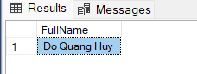
- Description: Find the employee(s) with the highest salary.
SELECT Full_Name, Salary FROM EMPLOYEE
WHERE Salary >= ALL (
SELECT Salary FROM EMPLOYEE
)
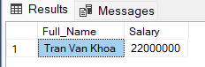
- Description: Get a list (CustomerID, FullName) of customers who have both an
ACCOUNT and a LOAN with the bank.
SELECT CustomerID, FullName FROM CUSTOMER
WHERE CustomerID IN (SELECT CustomerID FROM ACCOUNT)
INTERSECT
SELECT CustomerID, FullName FROM CUSTOMER
WHERE CustomerID IN (SELECT CustomerID FROM CUSTOMER_LOAN)
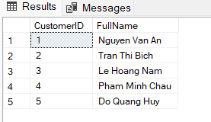
Functions
fn_CalculateCustomerAge
- Description: Calculates a customer's current age based on their Date of Birth (DOB).
CREATE FUNCTION fn_CalculateCustomerAge(@DOB DATE)
RETURNS INT AS
BEGIN
RETURN DATEDIFF(YEAR, @DOB, GETDATE());
END
- Execution:
SELECT CustomerID, FullName, dbo.fn_CalculateCustomerAge(DOB) AS Age
FROM CUSTOMER
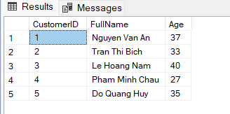
fn_GetCustomerTotalBalance
- Description: Calculates the total balance of a specific customer (CustomerID) by summing the balances of all their accounts.
CREATE FUNCTION fn_GetCustomerTotalBalance(@CustomerID INT)
RETURNS DECIMAL(18,2)
AS
BEGIN
DECLARE @TotalBalance DECIMAL(18,2);
SELECT @TotalBalance = SUM(Balance) FROM ACCOUNT
WHERE CustomerID = @CustomerID;
RETURN ISNULL(@TotalBalance, 0);
END
- Execution:
SELECT DISTINCT dbo.fn_GetCustomerTotalBalance(CustomerID)
AS Customer1TotalBalance
FROM ACCOUNT

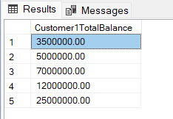
Stored Procedures
sp_AddNewCustomer
- Description: Inserts a new customer record into the CUSTOMER table.
CREATE PROCEDURE sp_AddNewCustomer
@CustomerID INT, @FullName NVARCHAR(100),
@DOB DATE, @Address NVARCHAR(255),
@Phone VARCHAR(20), @Sex VARCHAR(10)
AS
BEGIN
INSERT INTO CUSTOMER (CustomerID, FullName, DOB, Address, Phone, Sex)
VALUES (@CustomerID, @FullName, @DOB, @Address, @Phone, @Sex);
END
- Execution:
EXEC sp_AddNewCustomer 6, N'Ngo Huy Long', '1990-01-01', N'321 ABC Street, Da Lat', '0992645378', 'Male'
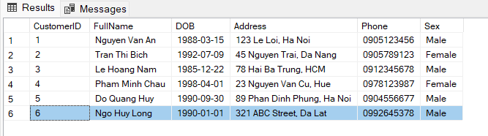
sp_MakeDeposit
- Description: Performs a simple deposit transaction. It updates the account's balance and inserts a record into the TRANSACTIONS table to log the event.
CREATE PROCEDURE sp_MakeDeposit
@AccountID INT,
@Amount DECIMAL(12, 2)
AS
BEGIN
IF @Amount <= 0
BEGIN
RAISERROR('Deposit amount must be positive.', 16, 1);
RETURN;
END

DECLARE @NextTransactionID INT;
SELECT @NextTransactionID = ISNULL(MAX(TransactionID), 0) + 1
FROM TRANSACTIONS;

UPDATE ACCOUNT SET Balance = Balance + @Amount
WHERE AccountID = @AccountID;

INSERT INTO TRANSACTIONS (TransactionID, TransactionType, Status, Amount, fromAccountID, toAccountID)
VALUES (@NextTransactionID, 'Deposit', 'Success', @Amount, NULL, @AccountID);

PRINT 'Deposit successful.';
END;
- Execution (Deposit 500,000):
EXEC sp_MakeDeposit @AccountID = 1, @Amount = 500000;
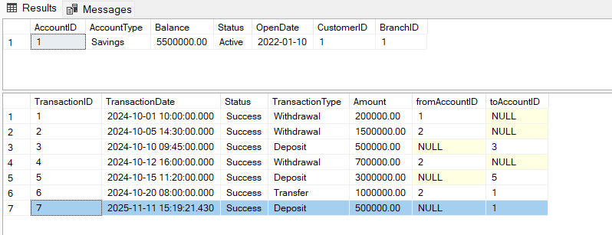
Triggers
Prevent branch deletion
- Description: This trigger prevents the deletion of a BRANCH record (parent record) if there are still associated child records (employees, accounts, or loans) linked to it. This helps ensure referential integrity.
CREATE TRIGGER trg_PreventBranchDeletion
ON BRANCH
INSTEAD OF DELETE
AS
BEGIN
DECLARE @BranchID INT;
SELECT @BranchID = d.BranchID FROM deleted AS d;

IF EXISTS (SELECT 1 FROM EMPLOYEE WHERE BranchID = @BranchID) OR
EXISTS (SELECT 1 FROM ACCOUNT WHERE BranchID = @BranchID) OR
EXISTS (SELECT 1 FROM LOAN WHERE BranchID = @BranchID)
BEGIN
RAISERROR('Cannot delete branch. Active employees, accounts, or loans are still associated.', 16, 1);
ROLLBACK TRANSACTION;
END
ELSE
BEGIN
DELETE FROM BRANCH WHERE BranchID = @BranchID;
END
END;
- Execution: The command fails and returns the error: "Cannot delete branch. Active employees, accounts, or loans are still associated."
DELETE FROM BRANCH WHERE BranchID = 1
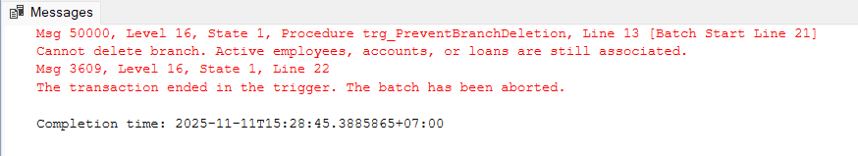
trg_PreventCloseAccountWithDebt
- Description: Enforces a critical business rule. This trigger prevents changing an
account's status to 'Closed' if the Customer who owns that account has any outstanding loans (any loan status other than 'Paid Off').
CREATE TRIGGER trg_PreventCloseAccountWithDebt
ON ACCOUNT
AFTER UPDATE
AS
BEGIN
IF EXISTS (SELECT 1 FROM inserted WHERE Status = 'Closed')
BEGIN
IF EXISTS (
SELECT 1 FROM inserted i
JOIN CUSTOMER_LOAN cl ON i.CustomerID = cl.CustomerID
JOIN LOAN l ON cl.LoanID = l.LoanID
WHERE i.Status = 'Closed' AND l.Status <> 'Paid Off'
)
BEGIN
RAISERROR ('Cannot close account. Customer still has outstanding loans.', 16, 1);
ROLLBACK TRANSACTION;
END
END
END;
- Execution: This will fail with error: Cannot close account. Customer still has outstanding loans.
UPDATE ACCOUNT SET Status = 'Closed' WHERE AccountID = 1;
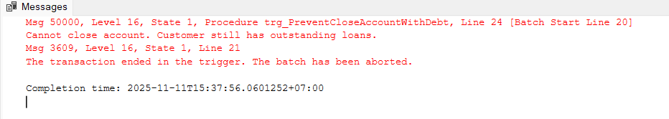
- Execution: The command succeeds (test case for AccountID = 2, whose owner has a 'Paid Off' loan).
UPDATE ACCOUNT SET Status = 'Closed' WHERE AccountID = 2;
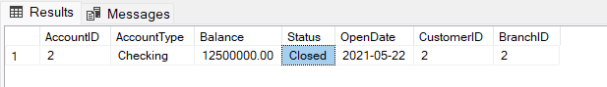
Create View and Index
View: vw_CustomerAccountDetails
- Description: Defines a view to simplify complex queries. This view provides a straightforward way to see customer account details without needing to write the JOINs manually.
CREATE VIEW vw_CustomerAccountDetails AS
SELECT
C.CustomerID, C.FullName, C.Phone,
A.AccountID, A.AccountType, A.Balance, A.Status AS AccountStatus,
B.BranchName
FROM CUSTOMER AS C
JOIN ACCOUNT AS A ON C.CustomerID = A.CustomerID
JOIN BRANCH AS B ON A.BranchID = B.BranchID;
- Execution:
SELECT * FROM vw_CustomerAccountDetails WHERE FullName LIKE N'Nguyen Van A%'
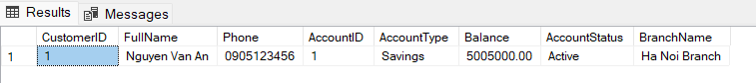
Index: idx_Account_CustomerBranch
- Description: Creates a composite index on the CustomerID and BranchID columns in the ACCOUNT table. This index is designed to improve the performance of queries that frequently filter or join on both the customer and their branch.
CREATE INDEX idx_Account_CustomerBranch
ON ACCOUNT(CustomerID, BranchID);
- Execution: Test query that benefits from the index.
SELECT AccountID, Balance FROM ACCOUNT
WHERE CustomerID = 1 AND BranchID = 1;
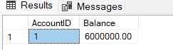

CONCLUSION

AI Utilization
AI tools (in study mode) were used as a supportive partner.
Design Phase: AI was prompted to validate our identified functional dependencies and to confirm that our proposed schema was consistent with 3NF normalization principles.
Implementation Phase: AI assisted in debugging and refining SQL code. For example, it helped validate the logic for the unified Transactions table, ensuring that the use of fromAccountID and toAccountID could correctly handle deposit, withdrawal, and transfer events, and helped refine the logic for the sp_MakeDeposit procedure.

Teamwork & Collaboration
    - Hà Nguyễn Tiến Đạt: Database Design & Core Schema
Role: Design and implement the overall database schema.
Details:
  - Define tables (Customer, Account, Employee, Branch, Loan, Transactions, Branch management, Customer loan).
  - Set up primary keys, foreign keys, and constraints.
  - Ensure data normalization and integrity.
  - Provide ERD diagram and schema documentation.
    - Trần Hữu Việt: Customer & Account Management
Role: Build customer and account management modules.
Details:
  - Implement APIs for add/edit/delete customers.
  - Implement APIs for create/update accounts (savings, current, fixed deposit).
  - Design a basic user interface for customer/account operations.
  - Ensure account status (active, closed, frozen) is properly managed.
    - Mai Thành Được: Transaction Management
Role: Develop transaction handling functions.
Details:
  - Build APIs to handle the unified transaction logic (processing different
TransactionType values within the single Transactions table ).
  - Ensure transaction ACID compliance and proper error handling.
  - Link transactions to audit log for traceability.
  - Generate transaction receipts for customer confirmation.
    - Lê Nguyên Ngọc: Loan, Security & Reporting
Role: Handle loan operations, security, and reporting features.
Details:
  - Implement APIs for loan applications, repayments, and loan status tracking.
  - Develop secure login system (username/password + optional MFA).
  - Maintain audit logging for employee/customer actions.
  - Create reports (e.g., transaction history, loan status, customer summaries).

